Android AVD Installation Documentation

**Step 1:** Open Android Studio and select ‘configure’.

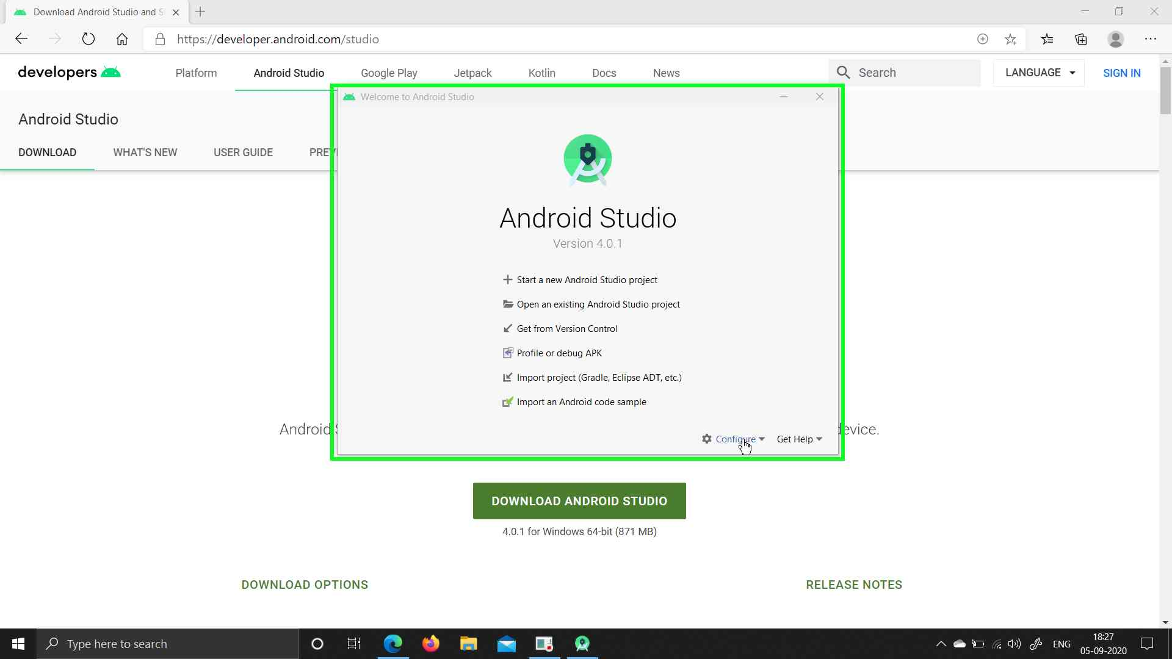

**Step 2:** Select AVD Manager

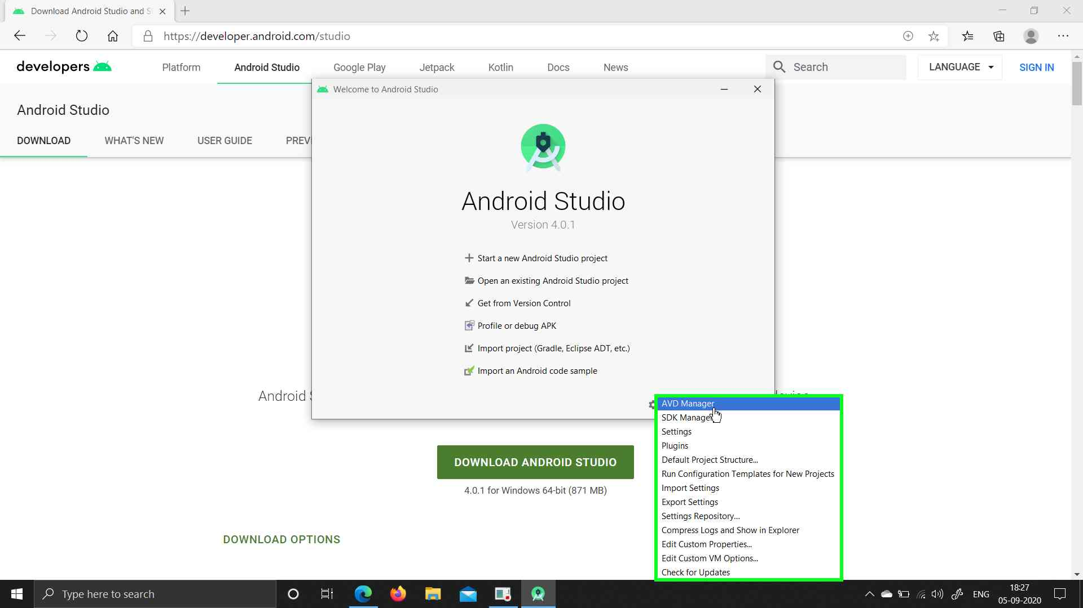

**Step 3:** Click on Create Virtual Device

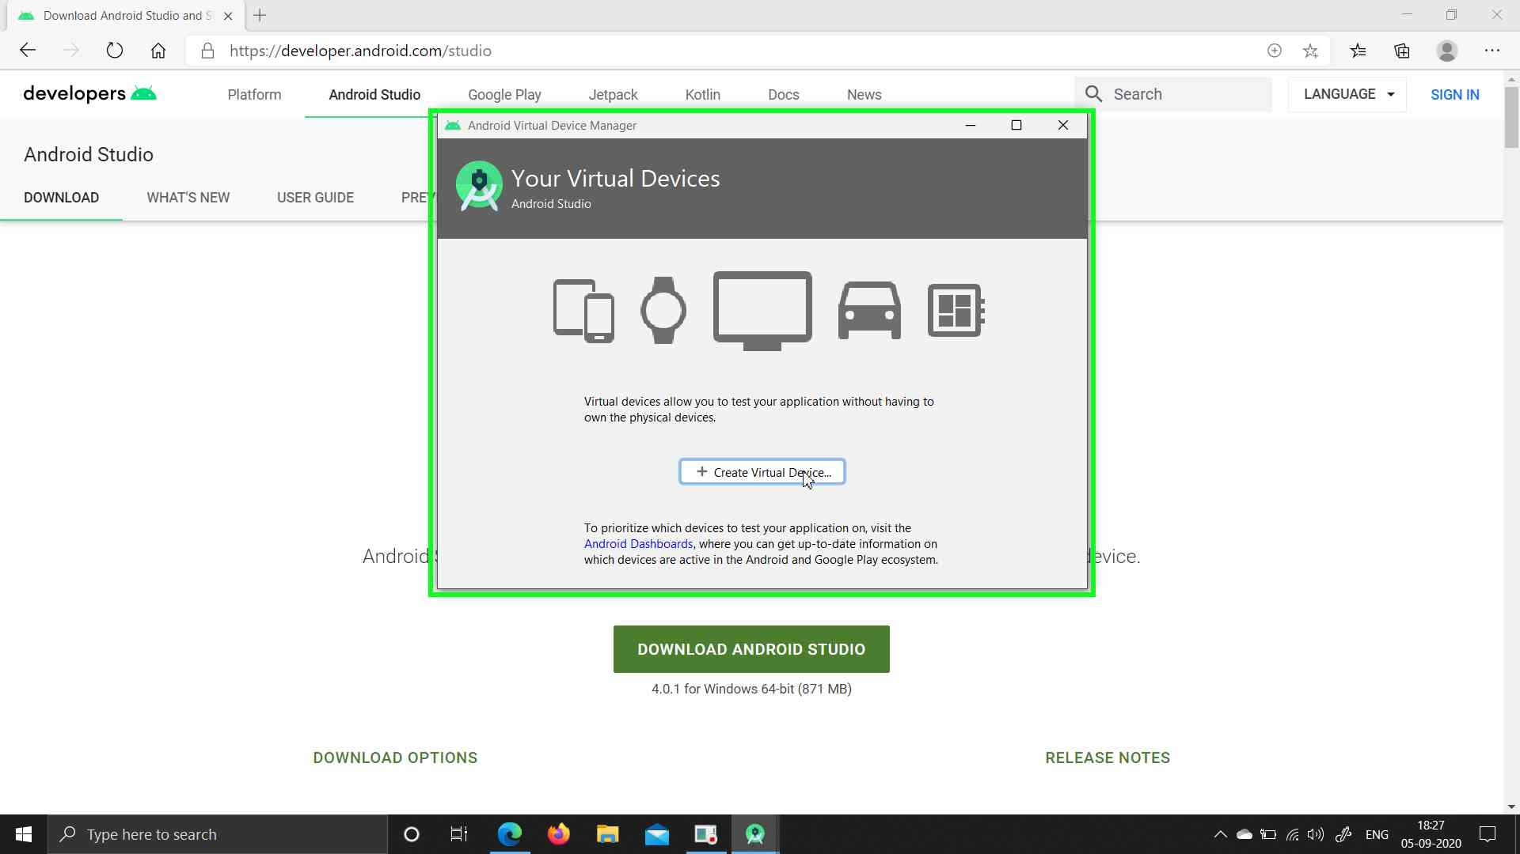

**Step 4:** Select a phone, preferably with no notches, (Either Pixel 2 or 3) and click Next

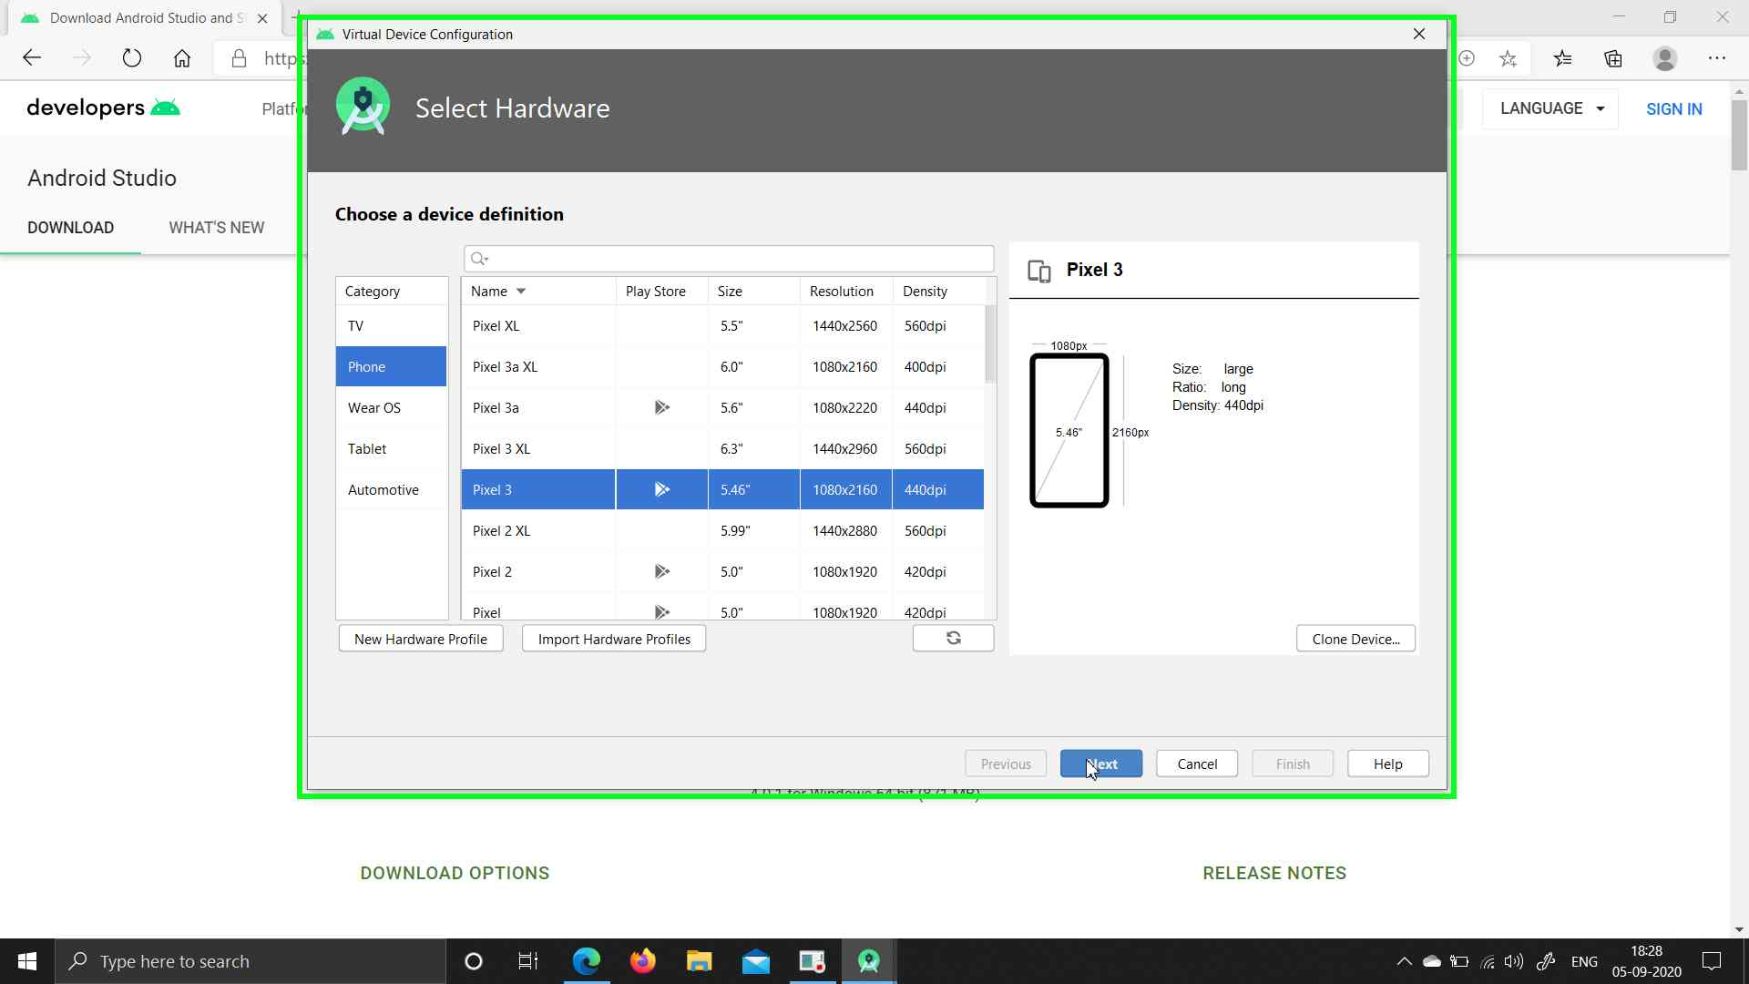

**Step 5:** Click on x86 Images and select a system image with Google APIs and x86_64 (if you have 64 bit architecture) and then click download.

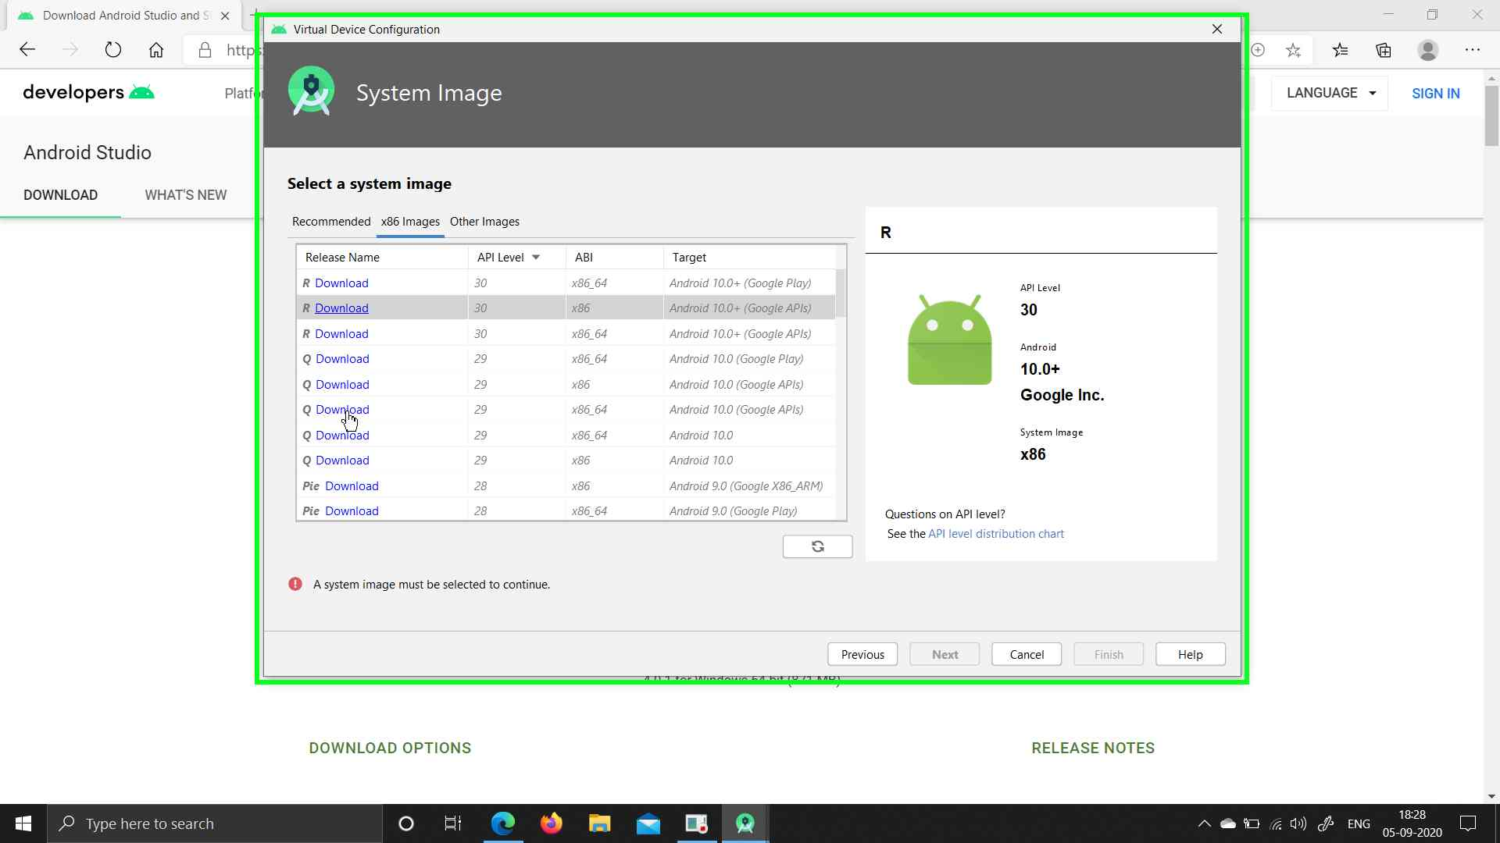

**Step 6:** Accept the Terms and Conditions and click Next

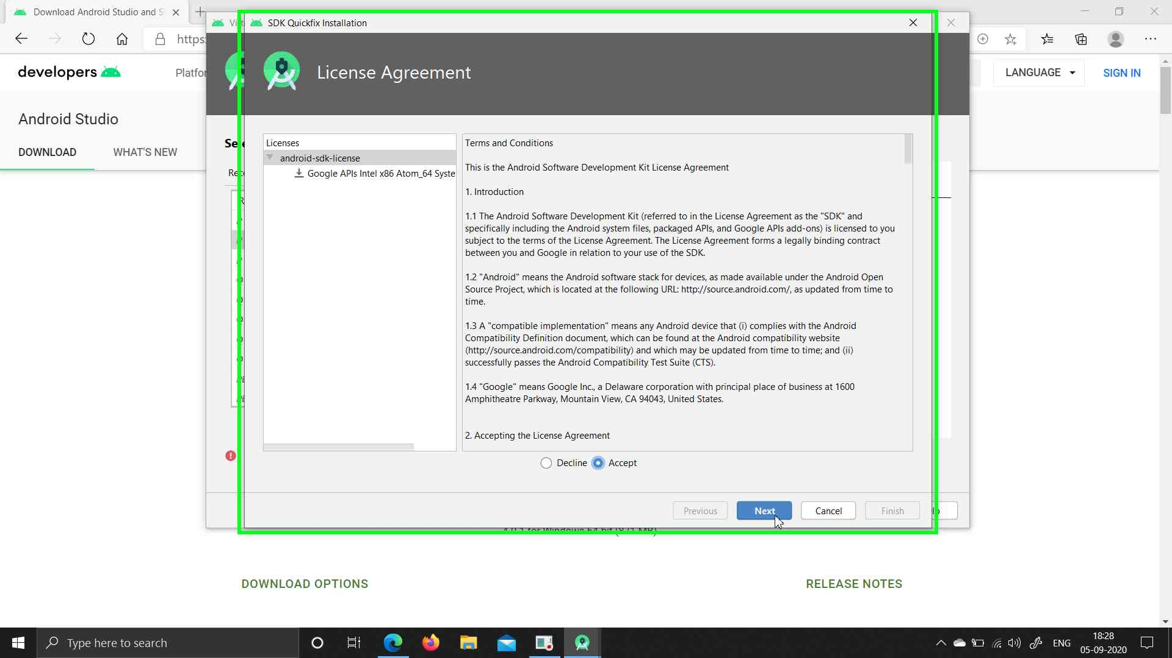

**Step 7:** Finish the Installation of the System Image

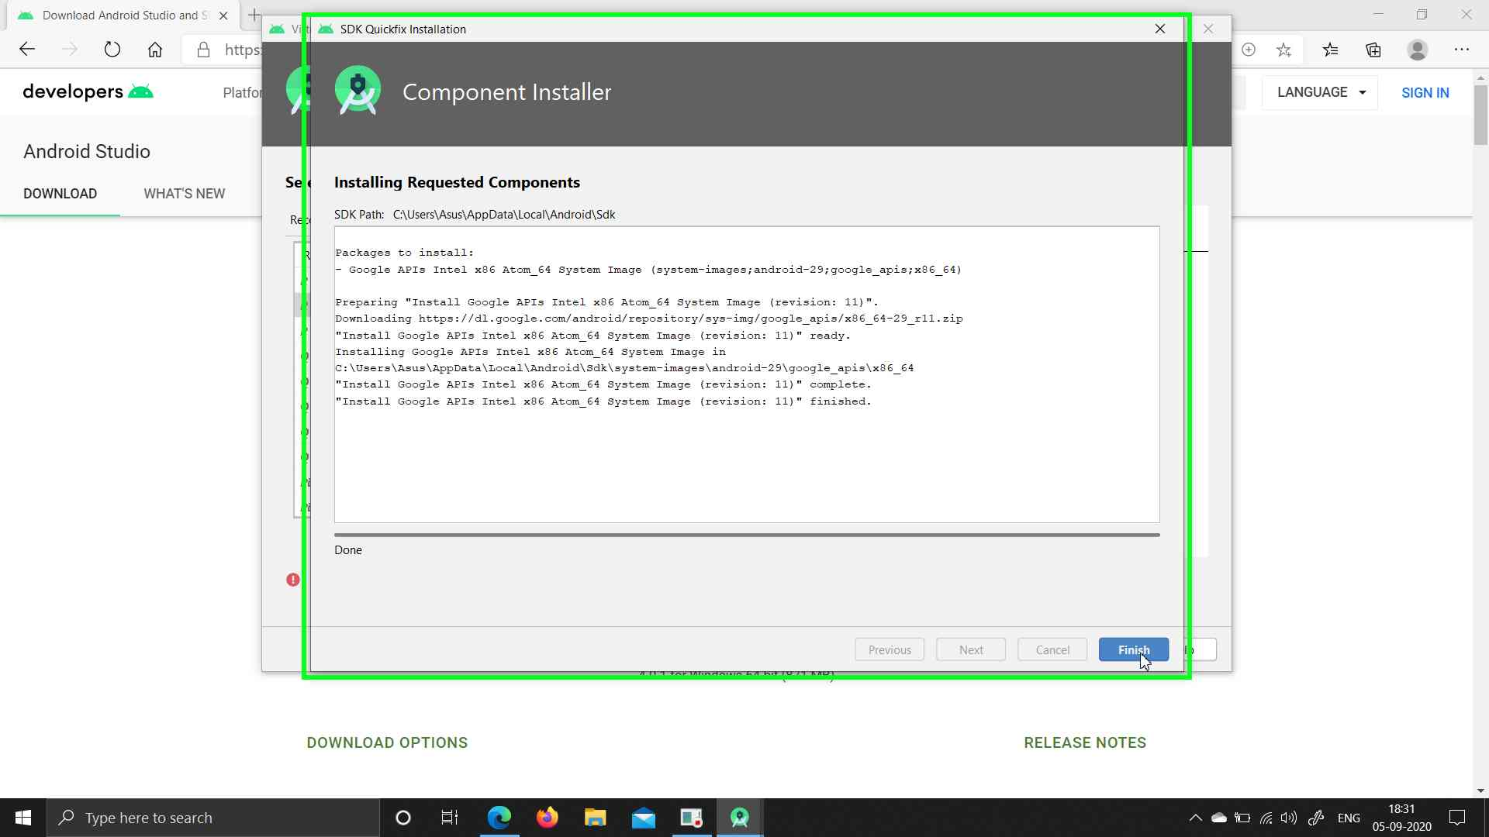

**Step 8:** Select the downloaded system Image and click Next.

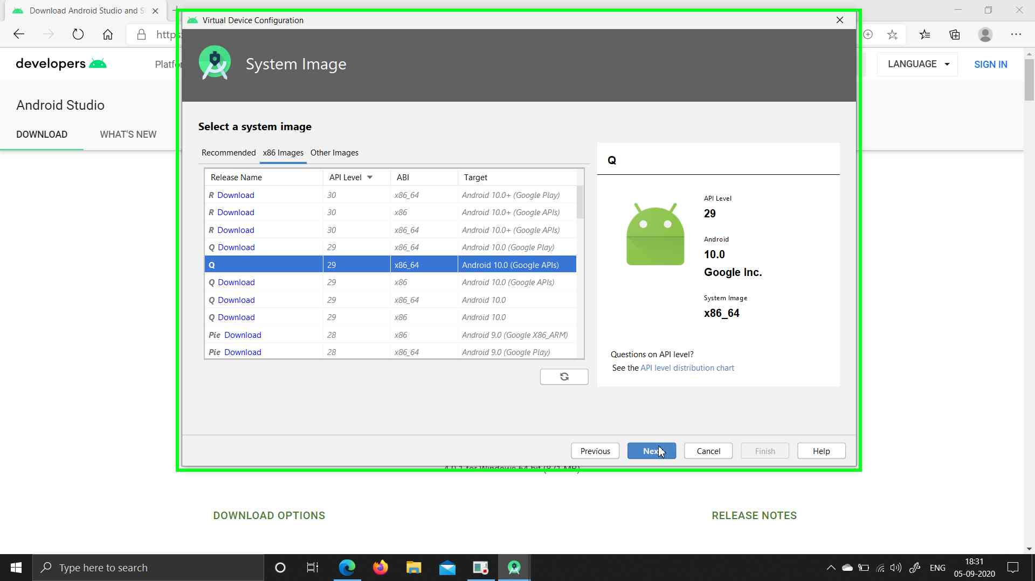

**Step 9:** Under Emulated Performance, select Hardware - GLES 2.0 to enable hardware acceleration (If you have dedicated GPU, skip if not)

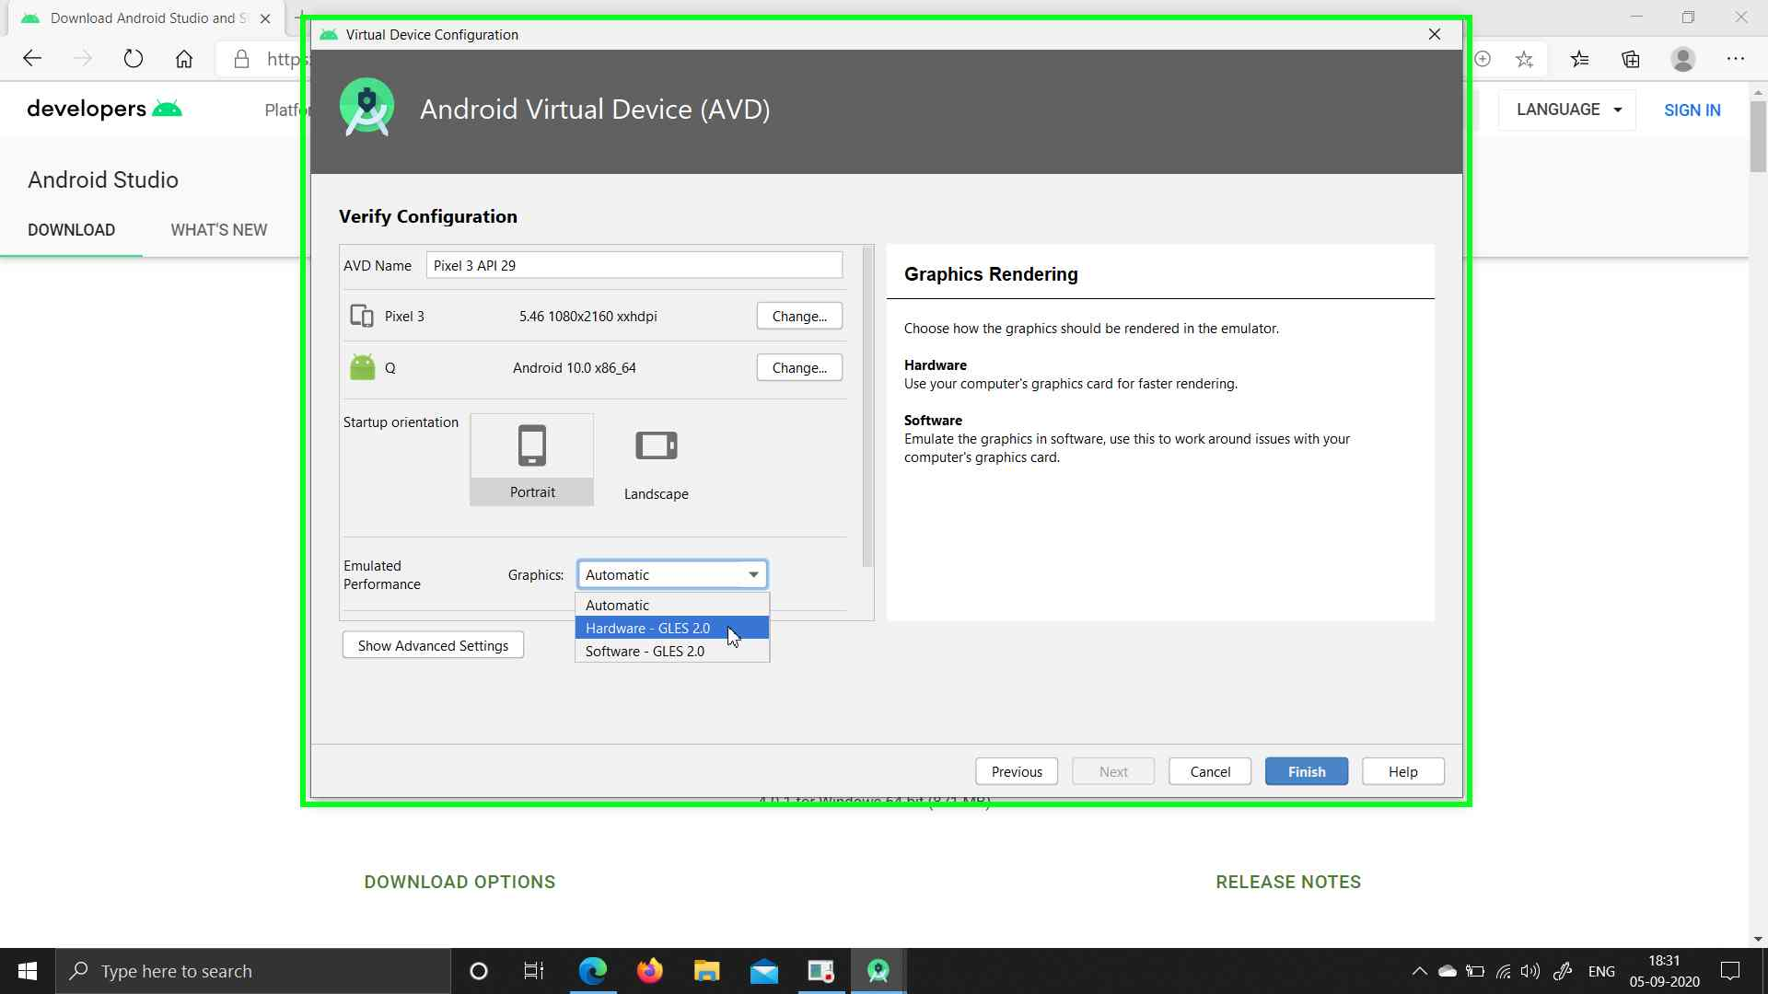

**Step 10:** Run the AVD

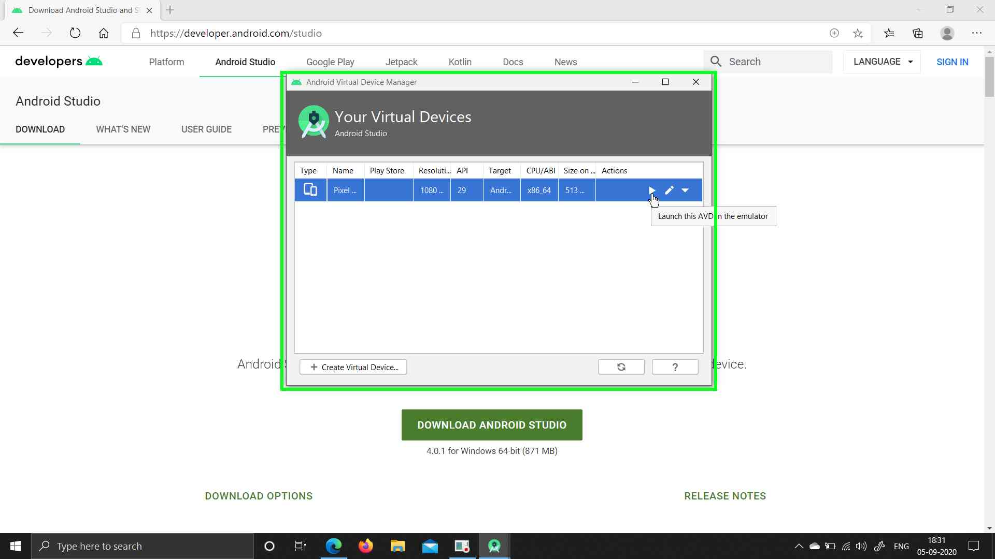

**Step 11:** AVD Setup is Complete

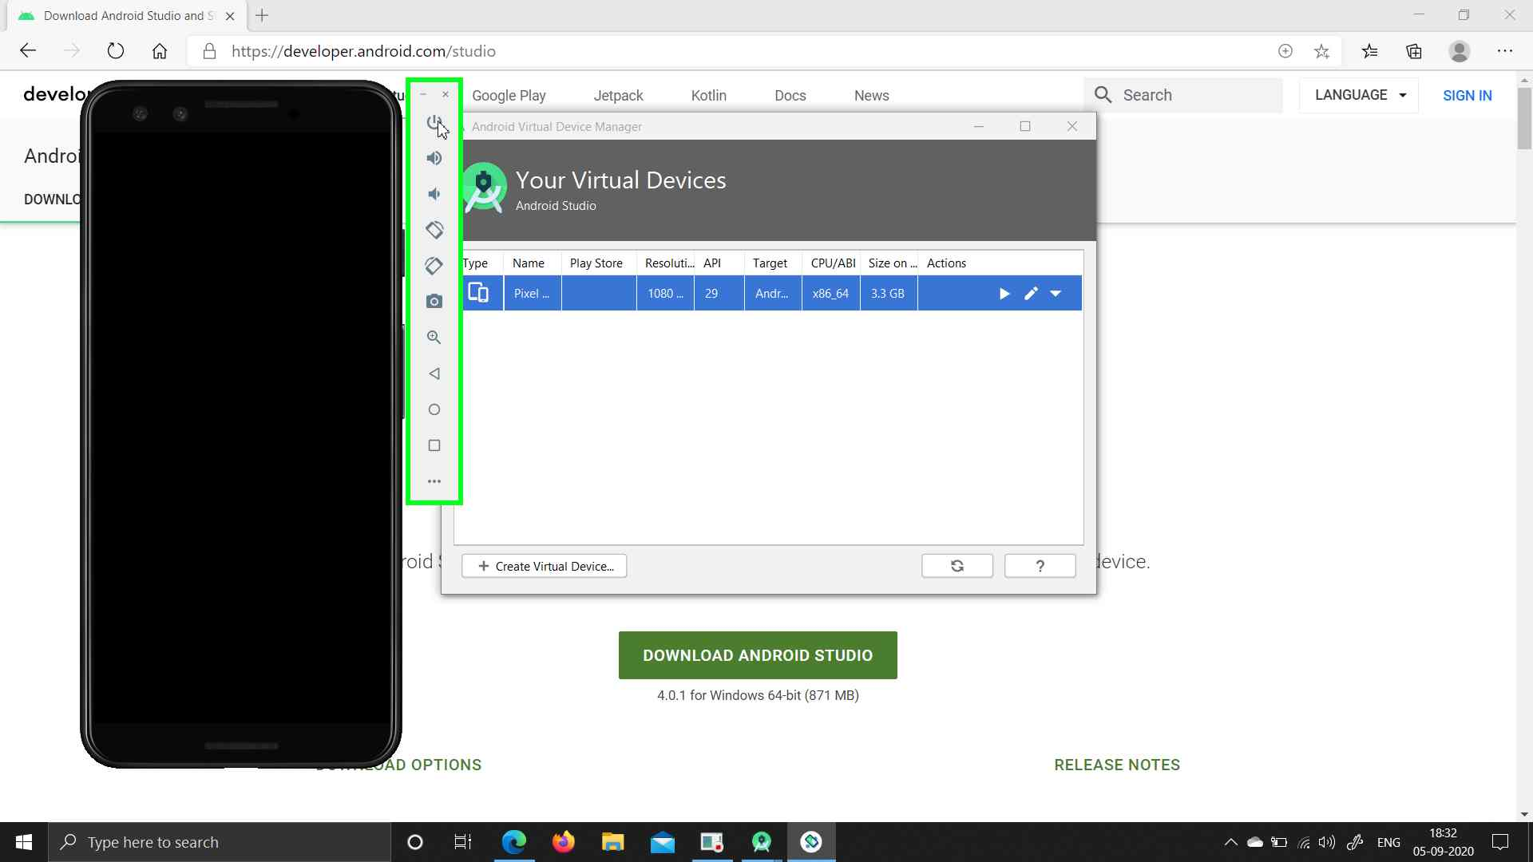

**Step 12:** AVD Setup is Complete

